Liberia

## Respect for rule of law (ROL) data

The data set shows the data on the respect of the rule of law for the country.

## # A tibble: 19 x 5  
## country iso3c date ruleOfLaw ruleOfLawCategory4   
## <chr> <chr> <dbl> <dbl> <chr>   
## 1 Liberia LBR 1996 -1.93 ROL highly disrespected   
## 2 Liberia LBR 1998 -1.93 ROL highly disrespected   
## 3 Liberia LBR 2000 -2.01 ROL highly disrespected   
## 4 Liberia LBR 2002 -1.81 ROL highly disrespected   
## 5 Liberia LBR 2003 -1.65 ROL highly disrespected   
## 6 Liberia LBR 2004 -1.56 ROL highly disrespected   
## 7 Liberia LBR 2005 -1.33 ROL highly disrespected   
## 8 Liberia LBR 2006 -0.888 ROL moderately disrespected  
## 9 Liberia LBR 2007 -0.890 ROL moderately disrespected  
## 10 Liberia LBR 2008 -1.09 ROL highly disrespected   
## 11 Liberia LBR 2009 -1.01 ROL highly disrespected   
## 12 Liberia LBR 2010 -0.961 ROL moderately disrespected  
## 13 Liberia LBR 2011 -0.927 ROL moderately disrespected  
## 14 Liberia LBR 2012 -0.887 ROL moderately disrespected  
## 15 Liberia LBR 2013 -0.879 ROL moderately disrespected  
## 16 Liberia LBR 2014 -0.806 ROL moderately disrespected  
## 17 Liberia LBR 2015 -0.864 ROL moderately disrespected  
## 18 Liberia LBR 2016 -0.957 ROL moderately disrespected  
## 19 Liberia LBR 2017 -0.966 ROL moderately disrespected

## Respect for rule of law (ROL) trend

The plot shows the trend of the respect for the rule of law for the country.

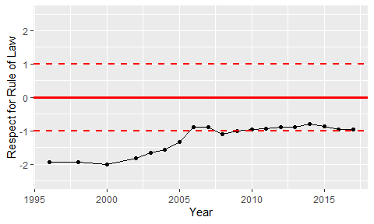

Trend of the Respect for the Rule of Law